SALISBURY AND SOUTH WILTSHIRE BRANCH

Monday 13th April 2026 at 11 a.m.
Archiving Salisbury Cathedral
with Emily Naish
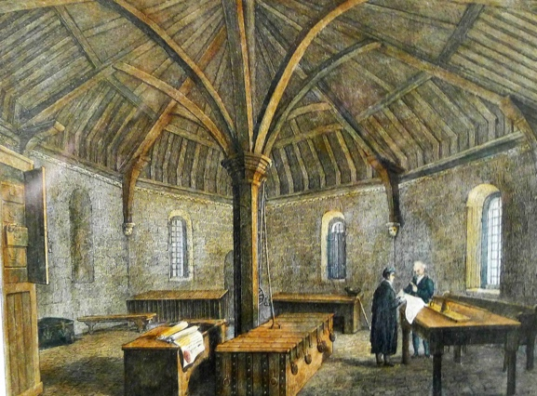
Medieval muniment room, Salisbury Cathedral

As Archivist and Collections’ Manager at Salisbury Cathedral, Emily is responsible for the custody and preservation of over 800 years of documented history from the 12th century to the present day. These range from medieval cartularies, deeds and accounts written in Latin on parchment to born digital emails and images. Magna Carta, of course, is a particularly special item but the archive seeks to represent all types of activities and communities at the Cathedral from official records to oral history and ephemera.

